**VISVESVARAYA TECHNOLOGICAL UNIVERSITY**

**“Jnana Sangama”, Belgaum - 590018**



## A DBMS MINI PROJECT REPORT ON

## “ Airline Management System ”

***Submitted in the partial fulfillment of the requirement for the fifth semester of***

**BACHELOR OF ENGINEERING**

***In***

**COMPUTER SCIENCE & ENGINEERING**

***By***

**Dewanshi (1RR18CS044)**

**Gagana CV (1RR18CS046)**

**Under the guidance of**

Associate Professor,

Dept. of CSE, RRCE



**DEPARTMENT OF COMPUTER SCIENCE & ENGINEERING**

**RAJARAJESWARI COLLEGE OF ENGINEERING**

**MYSORE ROAD, BANGALORE-560074**

**(An ISO 9001:2008 Certified Institute)**

**RAJARAJESWARI COLLEGE OF ENGINEERING**

**MYSORE ROAD, BANGALORE-560074**

**(An ISO 9001:2008 Certified Institute)**

**(Affiliated to Visvesvaraya Technological University, Belgaum)**



**DEPARTMENT OF COMPUTER SCIENCE & ENGINEERING**

Certified that mini project work entitled

***“AIRLINE MANAGEMENT SYSTEM”***

Carried out by

**DEWANSHI (1RR18CS044) and GAGANA CV (1RR18CS046)**

We, The students of **“Raja Rajeswari College of Engineering”** in partial fulfillment for the fifth semester of **Bachelor Of Engineering** in **Computer Science & Engineering** of the Visvesvaraya Technological University, Belgaum during the year **2020–2021.** It is certified that all corrections/suggestions indicated for Internal Assessment have been incorporated in the report deposited in the departmental library. The mini project report has been approved as it satisfies the academic requirements in respect of mini project work prescribed for the fifth semester.

**…………….................. ……………………………**

**Signature of guide Signature of HOD**

**[] [Dr.S Usha ]**

Associate Professor, Prof, Research Dean & HOD,

Dept. of CSE Dept. of CSE

RRCE, Bangalore RRCE, Bangalore

***External Viva-Voce***

***Examiners: Signature***

1. **_____________________**

**2.**  **______________________**

**CONTENTS**

**CHAPTERS Page No.**

**ABSTRACT**……………………………………………………………………........... 5

**ACKNOWLEDGEMENT**……………………………………………………….........6

**1. INTRODUCTION**………………………………………………………………….7

1.1 MANAGEMENT….……………………………………………………………….7

1.2 DBMS………………………………………………………………………………8

1.3 XAMPP mysql……………………………………………………………………..9

1.4 PROJECT AIM………………………………………………………………….....10

1.5 SCOPE……………………………………………………………………………. 11

**2. LITRATURE SURVAY….**…………………………………………………….........12

**3. PROPOSED SYSTEM….**…………………………………………………….........13

**4. SYSTEM REQUIREMENT**……………………………………………………….14

3.1 HARDWARE REQUIREMENT………………………………………………… 14

3.2 SOFTWARE REQUIREMENT……………………………………..…………….14

**5. SYSTEM DESIGN**………………………………………………………………….15

4.1 ER DIAGRAM……………………………………………………………………..15

4.2 SCHEMA DIAGRAM………………………………………………………….…..16

**6. IMPLEMENTATION….**…………………………………………………........... 17

**7. SNAPSHOTS**………………………………………………………………………19

**CONCLUSION**……………………………………………………………………….22

**BIBLIOGRAPHY**………………………………………………………………….....23

**LIST OF FIGURES**

**Fig. No. Figure Name Page No.**

1.1 DBMS ARCHITECTURE…………………………………………. 9

1.2 XAMPP……………………………………………………............. 10

5.1 ER DIAGRAM……………………………………………………... 15

5.2 SCHEMA DIAGRAM……………………………………………... 16

7.1 REGISTRATION PAGE……………………………….…………... 19

7.2 LOGIN PAGE…………………………………………….………... 19

7.3 FLIGHT DETAILS PAGE………………...…………..….…….…... 20

7.4 TICKET BOOKED PAGE.…….………………………….….…..…. 21

7.5 SEARCH FLIGHT PAGE……………….……………….….…….… 22

7.6 TICKET BOOKING PAGE……………………………………….………... 22

**ABSTRACT**

This project deals with the ‘Airline Management System’. The system is used for activities such as booking a flight. Airline reservation System is a computerized system used to store and retrieve information and conduct transactions related to air travel. The project is aimed at exposing the relevance and importance of Airline Reservation Systems. It is projected towards enhancing the relationship between customers and airline agencies. and thereby making it convenient for the customers to book the flights as when they require such that they can utilize this software to make reservations.

This software has two parts. First is user part and the administrator part. User part is used as a front end and administrator is the back end. Administrator is used by airline authority. It will allow the customers to access database and allow new customers to sign up for online access. The system allows the airline passenger to search for flights that are available between the two travel cities, namely the “Source” and “Destination” for a particular departure and arrival dates. The system displays all the flight’s details such as flight name, flight PNR, price and duration of journey etc.

After search the system display list of available flights and allows customer to choose a particular flight. Then the system checks for the availability of seats on the flight. If the seats are available then the system allows the passenger to book a seat. Otherwise it asks the user to choose another flight.

To book a flight the system asks the customer to enter his details such as name, address, city, state, and contact number. Then it checks the validity of card and book the flight and update the airline database and user database. The system also allows the customer to cancel his/her reservation, if any problem occurs.

The main purpose of this software is to reduce the manual errors involved in the airline reservation process and make it convenient for the customers to book the flights as when they require such that they can utilize this software to make reservations, modify reservations or cancel a particular reservation.

**ACKNOWLEDGEMENT**

We are truly thankful and convey our sincere gratitude to the principal, **Dr. Balakrishna R**, Rajarajeswari College of Engineering, Bangalore.

We, convey our sincere gratitude to **Dr. Usha S***,* HOD, Department of Computer Science & Engineering for her meticulous support, continuous co-operation, valuable suggestion and encouragement during the development of the project. We also extend our thanks for her invaluable guidance to imbibe the requisite knowledge for success of our project.

We, convey our sincere gratitude to **Dr. Sheba Selvam**, Associate Professor, Department of Computer Science & Engineering, for her meticulous support continuous co-operation, valuable suggestion and encouragement during the development of the project. We also extend our gratitude for her guidance to imbibe the requisite knowledge for success of our project, as an internal guide. We are very much obliged.

We also thank our parents who have encouraged us and supported us in every stage of development of this project.

Last but not the least, our wishes to the entire Computer Science Department for their help and guidance, encouragement, inspiration and co-operation at all stages of the development of this project without which this project wouldn’t have been a success.

Finally We express our heartfelt gratitude to all those who helped us to complete the project work successfully by providing support, suggestions, advise, guidance and much needed encouragement.

Dewanshi (1RR18CS044)

Gagana CV(1RR18CS046)

# CHAPTER 1

**INTRODUCTION**

## AIRLINE MANAGEMENT SYSTEM

Airline management system is a mini DBMS project built using HTML, PHP and MySQL used to store and retrieve data related to airline industry and make transaction related to air travel. The project is aimed at exposing the relevance and importance of airline reservation systems. With this project we aim to demonstrate the Create, Read, Update and Delete operations using MySQL database.

Airline management System will hold flight schedules and its fare tariffs, passenger

reservations and ticket records. It saves time as it allows online procedure as users no

longer to wait in a queue to book the flights. It is automatically generated by the server.

Admin is the main authority who can do addition, deletion, and modification of flights

if required. The project has been planned to be having the view of distributed architecture, with centralized storage of the database. The application for the storage of the data has

been planned. Using the constructs of Database and the user interfaces.

Today all persons are busy with their schedule and no one have time to make a trip for

holidays with their family. And this Airline Reservation Process is very difficult to

understand in General meaning. But we are providing a Solution for that Problem.

This system provides a facility to easy access towards a customers and a real time users.

They can easily connected through it and just few steps. There is no requirement for any

type of Agent. We are giving a all this facility in one project “Airline Management System”.

## DBMS

A database management system (DBMS) is system software for creating and mana[ging databases.](http://searchsqlserver.techtarget.com/definition/database) The DBMS provides users and programmers with a systematic way to create, retrieve, update and manage [data](http://searchdatamanagement.techtarget.com/definition/data).

A DBMS makes it possible for end users to create, read, update and delete [data](http://searchdatamanagement.techtarget.com/definition/data) in a database. The DBMS essentially serves as an interface between the [database](http://searchsqlserver.techtarget.com/definition/database) and end users or [application](http://searchsoftwarequality.techtarget.com/definition/application-program) [programs,](http://searchsoftwarequality.techtarget.com/definition/application-program) ensuring that data is consistently organized and remains easily accessible. The DBMS manages three important things: the data, the database [engine](http://whatis.techtarget.com/definition/engine) that allows data to be accessed, locked and modified and the database [schema,](http://searchsqlserver.techtarget.com/definition/schema) which defines the database’s logical structure. These three foundational elements help provide [concurrency,](http://searchoracle.techtarget.com/definition/concurrent-processing) security, [data integrity](http://searchdatacenter.techtarget.com/definition/integrity) and uniform administration procedures.

Typical database administration tasks supported by the DBMS include [change management](http://searchcio.techtarget.com/definition/change-management), performance monitoring/tuning and [backup](http://searchstorage.techtarget.com/definition/backup) and [recovery](http://searchstorage.techtarget.com/definition/recovery). Many database management systems are also responsible for automated [rollbacks](http://searchsqlserver.techtarget.com/definition/rollback), restarts and recovery as well as the [logging](http://whatis.techtarget.com/definition/log-log-file) and [auditing](http://searchcio.techtarget.com/definition/audit-trail) of activity. The DBMS is perhaps most useful for providing a centralized view of data that can be accessed by multiple users, from multiple locations, in a controlled manner. A DBMS can limit what data the end user sees, as well as how that end user can view the data, providing many views of a single database schema. End users and software programs are free from having to understand where the data is physically located or on what type of storage media it resides because the DBMS handles all requests.

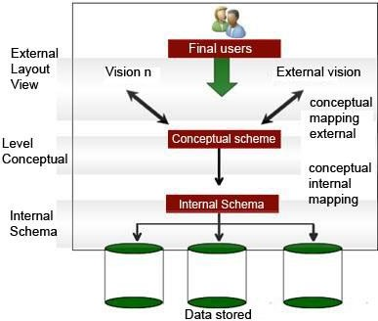

**Fig 1.1: DBMS Architecture**

## XAMPP MySQL

XAMPP is a free and open source cross-platform web server solution stack package developed by Apache friends, consisting mainly of the Apache HTTP Server, MariaDB database, and interpreters for scripts written in PHP and Perl programming languages. XAMPP stands for Cross-Platform (X), Apache (A), MariaDB (M), PHP (P) and Perl (P). It is a simple, lightweight Apache distribution that makes it extremely easy for developers to create a local web server for testing and deployment purposes. Everything needed to set up a web server – server application (Apache), database (MariaDB), and scripting language (PHP) – is included in an extractable file. XAMPP is also cross-platform, which means it works equally well on Linux, Mac and Windows. Since most actual web server deployments use the same components as XAMPP, it makes transitioning from a local test server to a live server extremely easy as well. XAMPP is regularly updated to the latest releases of [Apache,](https://en.wikipedia.org/wiki/Apache_HTTP_Server) [MariaDB,](https://en.wikipedia.org/wiki/MariaDB) [PHP](https://en.wikipedia.org/wiki/PHP) and [Perl](https://en.wikipedia.org/wiki/Perl). The term XAMPP is an apparent acronym. This is regularly updated to the regular releases of Apache, MariaDB, Perl and PHP.



**Fig 1.2: XAMPP**

## PROJECT AIM

This project deals with the ‘airline management’. The main objective of the project on airline reservation system is to manage the details of Airlines, Tickets, Flights, Bookings, Customers. It manages all the information about Airline Tickets, Venders, Booking Counters, Airlines Tickets. The project is totally built at administrative end and thus only the user is guaranteed the access. The purpose of the project is to build an application program to reduce the manual work for managing the Airline Tickets, Flights Vendors Bookings. It tracks all the detail about the Bookings, Customers, Booking Counters.

It provides the facility to manage the information of flight. Shows the information and description of Airlines, Ticket Bookings. It helps to increase the efficiency of managing the Airlines Ticket, Flights. It deals in monitoring the information and transactions of the Customers.

## SCOPE

It may help in collecting correct management in detail. In a very short time the collection will be obvious, simple and sensible. It will help a person to know the management of passed year perfectly and vividly.

It also helps in current all works relative to airlines reservation system. It will be also reduced the cost of collecting the management and collection procedure will go on smoothly. Our project aims in business process automation, ie. We have tried to computerize various processes of Airline Reservation System. In computer system the bperson has to fill the various forms and number of copies of the forms can be easily generated at a time. In computer system it is not necessary to create the manfiest but we can directly print it, which saves our time. To assist the staff in capturing the effort spent on the respective working areas. To utilize resources in an efficient manner by increasing their productive through automation. The system generates types of information that can be used for various purposes.

It satisfies the user requirements. It will be easier to understand by the user and operator. It has a good user interface. It can be expandable. It can be delivered on schedule within the budget. This project satisfies most of the user requirements. It is easy to understand by the user and operator. It has a good interface and can be expandable. This project works on WINDOWS platform.

# CHAPTER 2

**LITERATURE SURVEY**

In the arena of global competition, organizations in all over the world are competing through the use of the most comprehensive and advanced technological feature. The most common example of innovation is in the area of information technology and communication. Various industries are using the technologies and the advancements of software and Internet to maintain and monitor their business transactions. In the application of the informative systems, the airline industry is the most common users of the system. The purpose of the application of system is to easily manage and organize all the reservations and bookings of the clients and gain the competitive advantage. Some of the popular airlines that use the various reservations systems are the British Airways, Virgin Atlantic Airlines, Singapore Airlines, Cathay Pacific, and Qantas, and many others. All of the airlines are founded in different years, following different routes, having unique organizational structure and models and yet covers the system that gained them popularity. The existing manual system has got many disadvantages. It is time consuming job and is difficult to maintain records manually. So we go for computerization of the system for effective management. In the existing system first of all the passengers place their consignments like covers, documents, non documents etc. to the officer of the airline branch. Here this branch acts as a source branch. Then the branch officer prepares the consignment note which includes several details like date, insurance, weight in kilograms and grams etc. The billing in the existing system is done via online. So for the billing procedure of the regular customer all the reports have to be checked. This is a long, time consuming process. To overcome these drawbacks automation of the existing system is done which can be used efficiently and by people with basic computer knowledge It provides the facility to manage the information of flight. Shows the information and description of Airlines, Ticket Bookings. It helps to increase the efficiency of managing the Airlines Ticket, Flights. It deals in monitoring the information and transactions of the Customers.

# CHAPTER 3

**PROPOSED SYSTEM**

The proposed system is better and more efficient than existing system. The system is proposed by keeping in mind all the drawbacks of the present system to provide a permanent solution to them.

The primary aim of the new system is to speed up the transactions. User friendliness is another peculiarity of the proposed system. Messages are displayed in message boxes to make the system user friendly. Every record is checked for completeness and accuracy and then it is entered into the database. The comments and valid messages are provided to get away redundant data. It takes the current date i.e. system date so date need not be entered every time.

The proposed system has the following requirements:

* + - System needs store information about new entry of User.
    - System needs to help the internal staff to keep information of Flights and find them as per various queries.
    - System need to maintain quantity record.
    - System need to keep the record of Bookings.
    - System need to update and delete the record.
    - System also needs to search the Flights.

# CHAPTER 4

**SYSTEM REQUIREMENT**

## Hardware Requirements

|  |  |  |
| --- | --- | --- |
| * PROCESSOR | : | INTEL P-4 BASED SYSTEM |
| * PROCESSOR SPEED | : | 2.0 GHz |
| * RAM | : | 256MB-512MB |
| * HARD DISK | : | 40GB-80GB |

* 1. **Software Requirements**

|  |  |  |
| --- | --- | --- |
| * OPERATING SYSTEM | : | WINDOS/LINUX |
| * LANGUAGE | : | PHP, HTML/CSS, JavaScript |
| * BROWSER | : | GOOGLE CHROME/FIREFOX |

**CHAPTER 5**

**SYSTEM DESIGN**

* 1. **ER DIAGRAM**

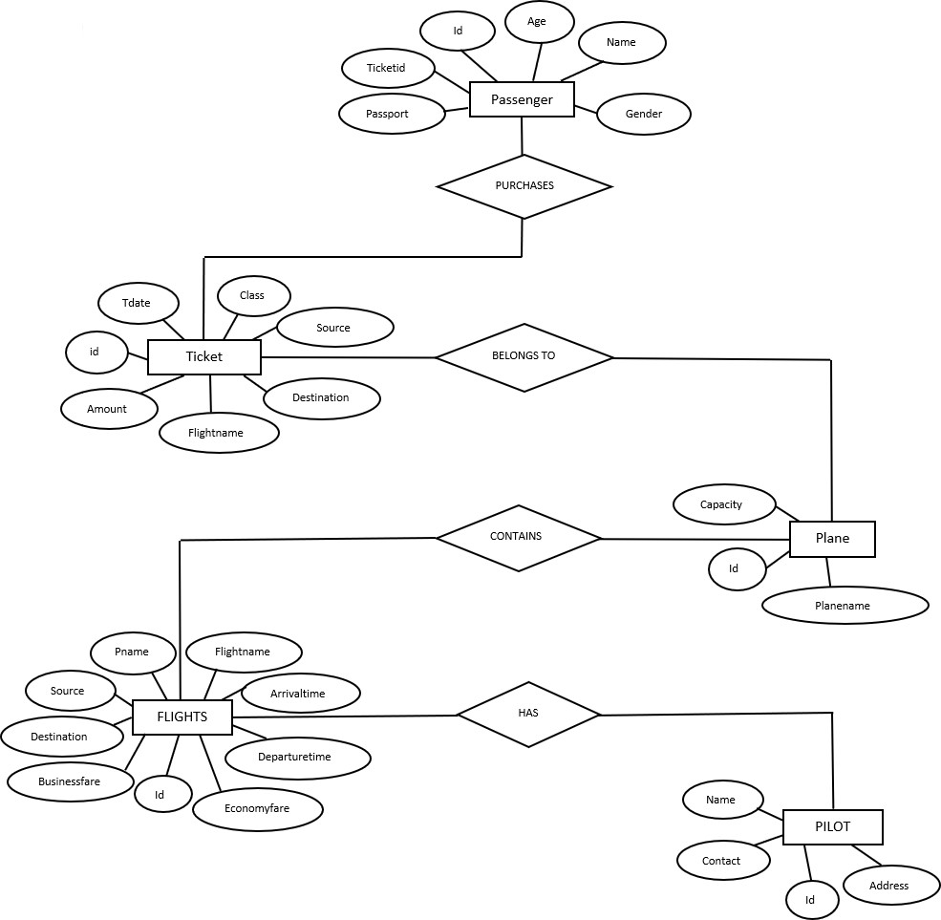

**Fig 5.1: ER diagram**

* 1. **SCHEMA DIAGRAM**

### Users

|  |  |  |  |  |  |
| --- | --- | --- | --- | --- | --- |
| Id | username | email | password | Reg_date | role |

**Ticket**

|  |  |  |  |  |  |  |
| --- | --- | --- | --- | --- | --- | --- |
| Id | username | flight name | Flight PNR | Date | Time | Price |

**Flights**

|  |  |  |  |
| --- | --- | --- | --- |
| Flight name | Flight PNR | Time | Price |

**Plane detail**

|  |  |  |
| --- | --- | --- |
| Flight name | Flight PNR | Capacity |

**Fig 5.2: Schema Diagram**

**CHAPTER 6**

**IMPLEMENTATION**

The proposed system of Airline Management System consists of:

* + - Flight details
    - Plane details
    - Passenger details
    - Ticket booking

## Flight details

This module is used to view the flight details with ease and it tends the passenger to book tickets without much difficult. This consists of Flight name, flight PNR, Fare, source, destination, Departure time, arrival time.

### Algorithm

Step1: start

Step2: enter flight name, flight PNR, fare

Step3: enter the source, destination, time

Step4: click on add flight

Step5: stop

## Plane details

This module is used to view the plane details with ease and it tends the passenger to book tickets without much difficult. This consists of flight name, flight PNR, Capacity.

### Algorithm

Step1: start

Step2: enter flight name, capacity Step3: click on add plane

Step4: stop

## Passengers details

This module is used to view the passenger details. Here the details of the passenger can be viewed with the help of the ticket id issued after booking. This consists of name, email id, password.

### Algorithm

Step1: start

Step2: enter name, email id, password.

Step3: click on add passenger.

Step4: stop

## Ticket booking

This module is used to book the tickets after checking the availability of the tickets in the flights. This consists of date, source, destination, flight name, class, and passengers detail (name, flight name, flight PNR, Date, Price.),

### Algorithm

Step1: start

Step2: enter date, source, destination, flight name, class Step3: enter name, flight name, flight PNR, Price, Date

Step4: click on submit Step5: stop

# CHAPTER 7

**SNAPSHOTS**

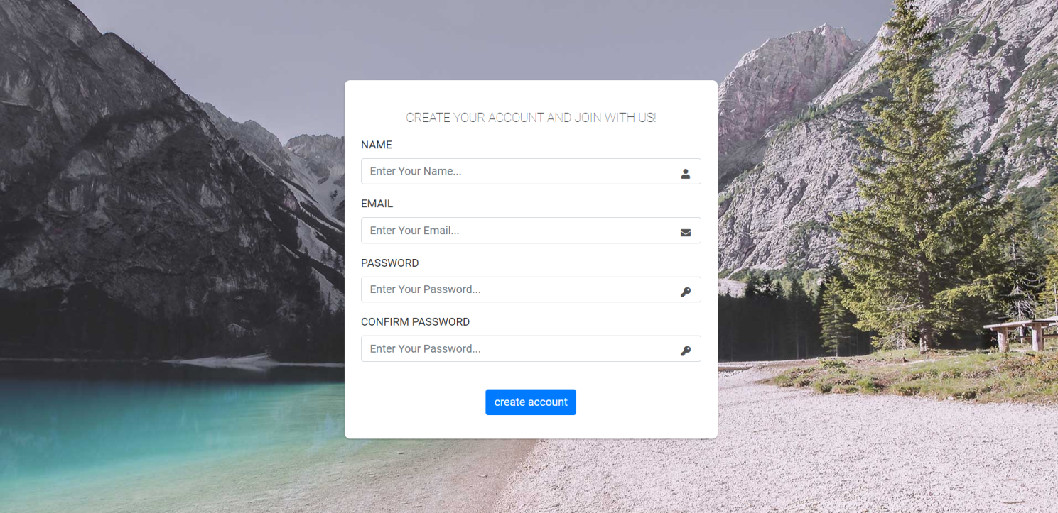

## 

## 

## Fig 7.1: Registration Page

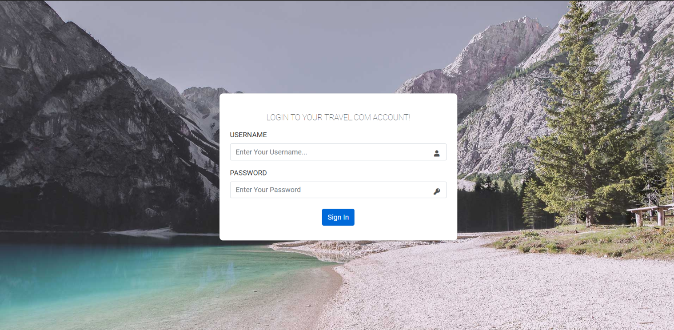

**Fig 7.2: Login page**

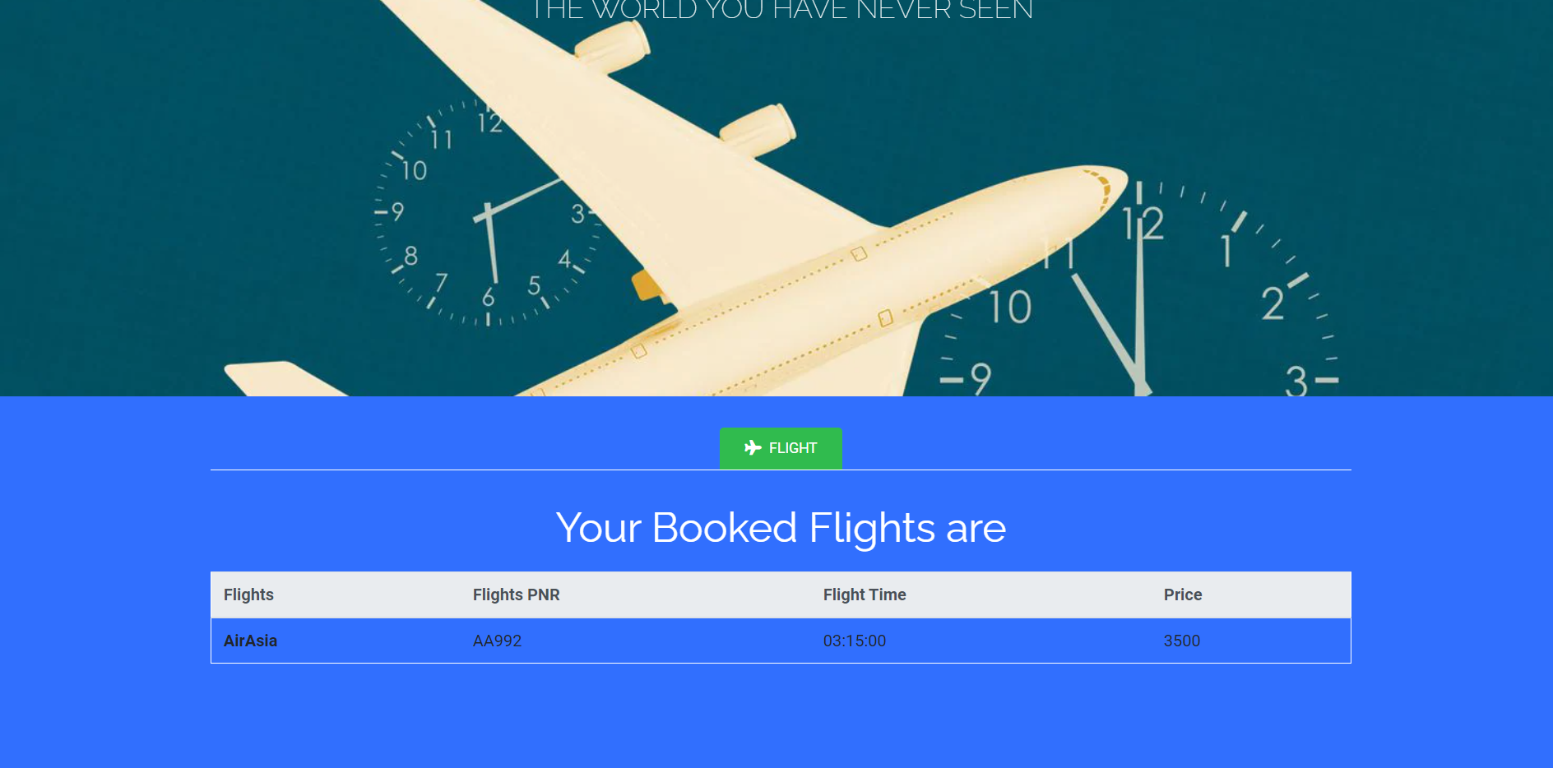

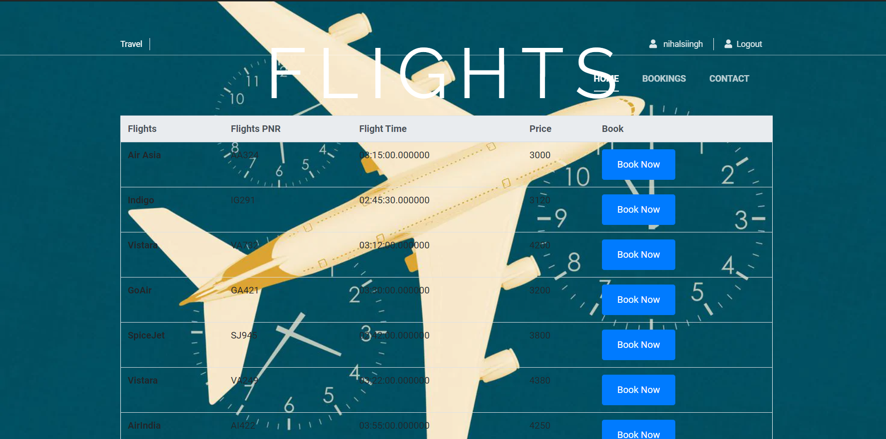

**Fig 7.3: Ticket Booked Page**

**Fig 7.4: Search Ticket Page**

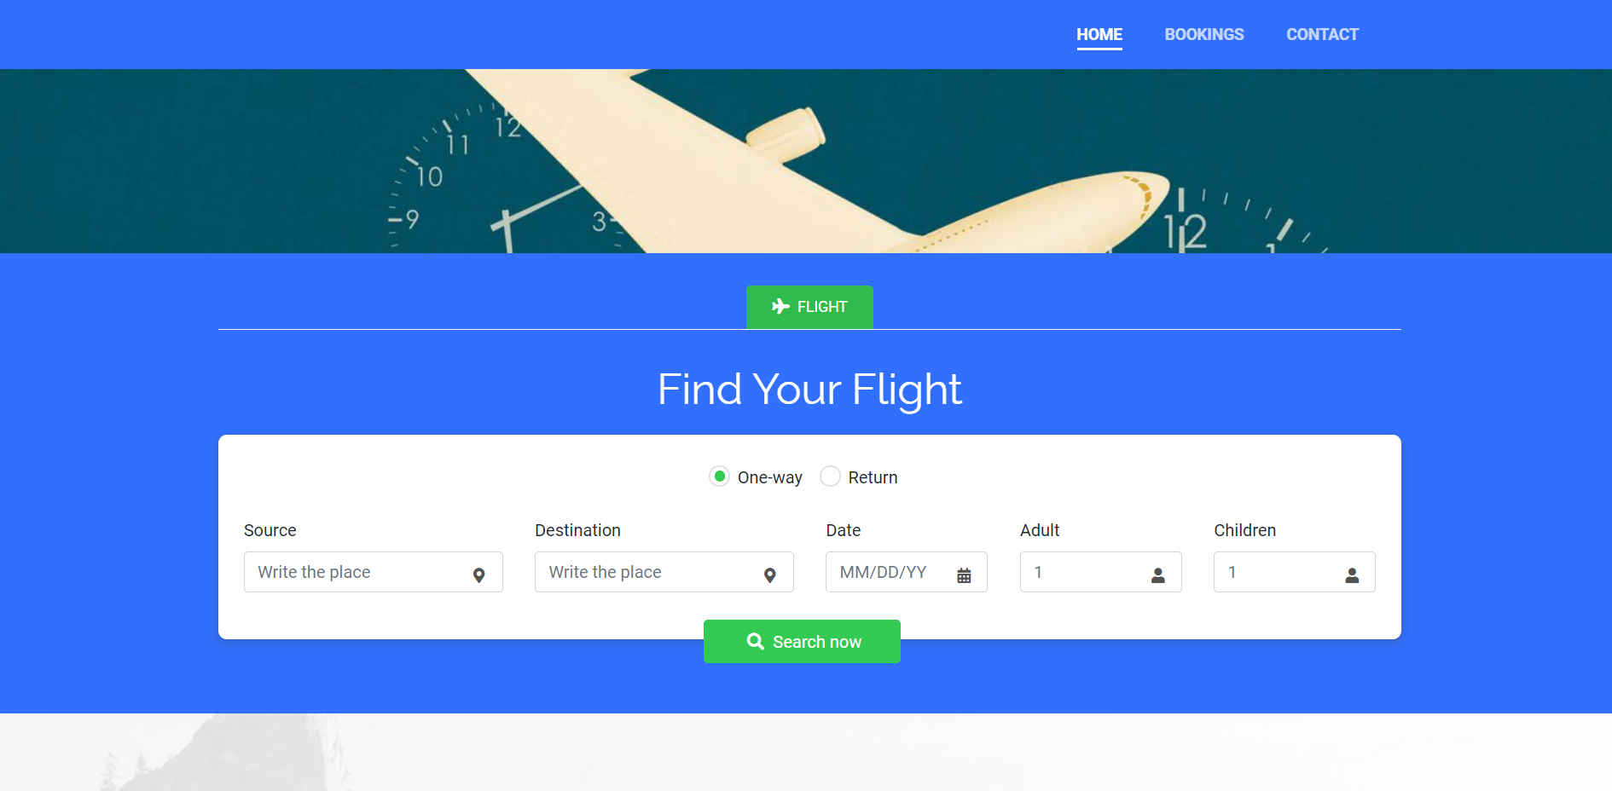

**Fig 7.5: Search Flight Page**

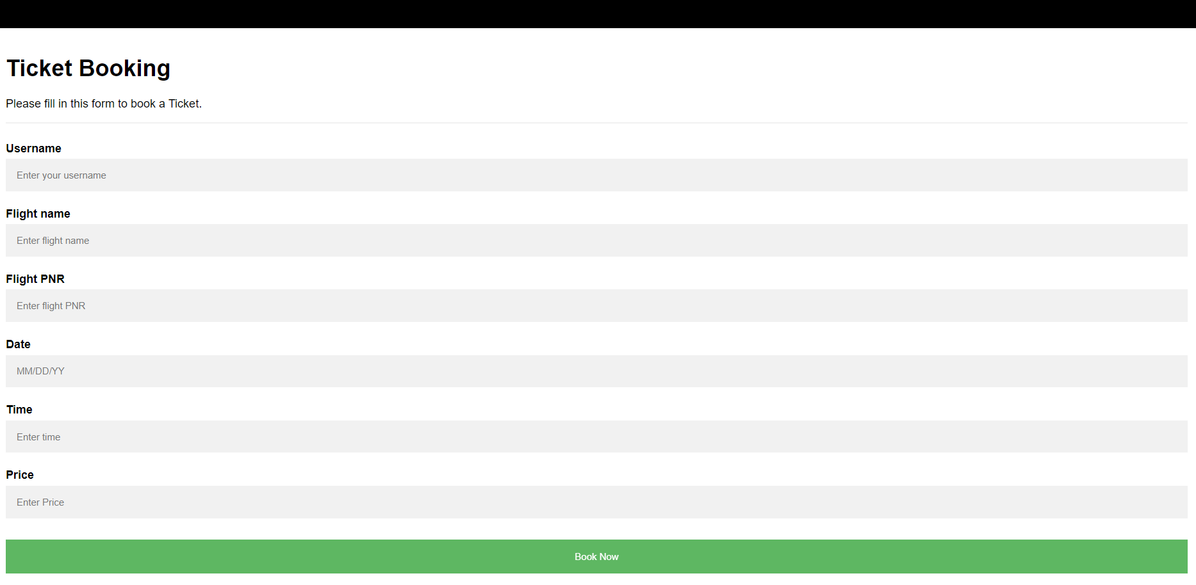

**Fig 7.5: Search Flight Page**

**CONCLUSION**

The entire project has been developed and implemented as per the requirements of the user. It is found to be bug free as per the testing standard that is implemented. Any specification untraced error will be concentrated in the coming versions, which are planned for development in near future. The system was successful in depicting the aim. As the system developed was successful in depicting the operation of Time-Table Generation, it can automatically integrate with some more features. Instead of struggling with existing system with hectic procedures it is more easy and stress free to use the proposed system so that user and interact and send the consignments easily and quickly to the correct destination without the need of any large reports, etc.

# BIBILIOGRAPHY

1. [http://www.google.com](http://www.google.com/)
2. [http://www.microsoft.com](http://www.microsoft.com/)
3. [http://www.codeproject.com](http://www.codeproject.com/)
4. [http://www.msdn.com.](http://www.msdn.com./)
5. [http://www.vb123.com](http://www.vb123.com/)
6. [http://www.vbcode.com](http://www.vbcode.com/)
7. [http://www.sqltuner.com](http://www.sqltuner.com/)
8. Google for problem solving
9. Fundamentals of Database system by Elmasri Namathe